Jan 19th 2025 TI game

Discordant Stars Introductory Game

Game details
6 players. 12 point game. 4-Ring Map

Player | Paul | Tanya | Will
Faction | L’tokk Khrask | Free Systems Compact | Kollecc Society
Final Score | 12 (Winner*) | 11 | 10

Player | Tim | Steve | KP
Faction | Augers of Ilyxum | Veldyr Sovereignty | Vaden Banking Clans
Final Score | 9 | 9*  (12, and the Strategic Victory/Win) | 7

Small Recap:
Paul rushed to an early lead, and held it through the game (widest gap being a 3 point lead in round 4). Steve pushed for a valiant round 5 and 6 (4 points in round 5, and gearing up for another 3 in round 6). After a hectic round 6 including: The introduction of a steal-able victory point relic (that both Paul and Tanya failed to steal from Will), Steve had heroically re-taken his home system, had re-taken mecatol, and was about to Imperial his way to victory. Unfortunately, the birthday boy undercut this victory by handing Paul the support for the Throne for the win and granting Paul his first “gimme” win at the Burlington table.

Map
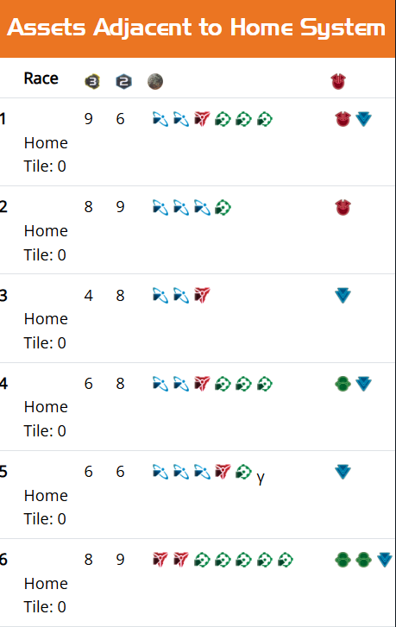
TI4 Map Generator (Keeganw Builder) Direct Link

Fixed Map (Had 2 of the same system before)

Static Image of Map

Keegmaw Map String 37 33 71 4258 28 38 4271 4272 62 39 27 47 35 4270 69 40 4264 79 30 4255 29 4262 4256 41 4257 66 4274 59 4269 48 74 4253 50 76 4254 67 0 4263 4260 4259 0 65 64 34 0 4268 25 4267 0 4266 26 60 0 4261 4275 70 0 4265 4276 32

TI Assistant Map String 37 33 71 4242 28 38 4255 4256 62 39 27 47 35 4254 69 40 4248 79 30 4239 29 4246 4240 41 4241 66 4258 59 4253 48 74 4237 50 76 4238 67 0 4247 4244 4243 0 65 64 34 0 4252 25 4251 0 4250 26 60 0 4245 4259 70 0 4249 4260 32

Map is designed to feature a game that should fully enable a wild test of new components. Balance is unknown, but there was some intention to the design.

The map features 7 legendary planets (1 per slice) + a dedicated gamma wormhole to Malice. It also features plentiful wormholes to keep this big map small.

Uncharted Space Legendary Planet Abilities
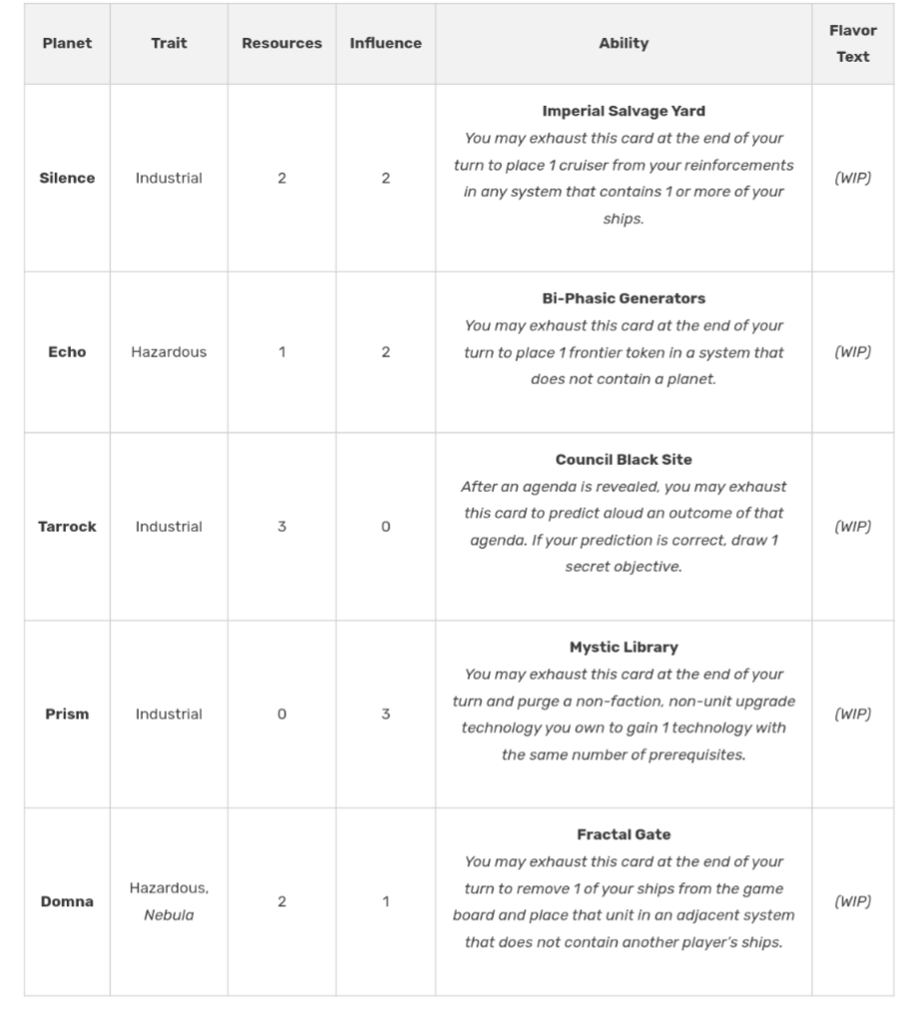

Faction Selection
A return to good ol’ Draw 3, Pick 1. I'll deliver 3 options to you, and you will play one of those options. You can draw up to 2 new factions.

We will allow 30 min at the start of game to finalize decisions (if needed).

Organizer notes:
This is not a “poor universe.” I expect people to be flush with resources and influence, so I think a 12 point game is the right call. Should let every faction have some room to play, and not be hindered by low resources and influence.

This game introduces Discordant Stars (factions) and Uncharted Stars components (systems, action and exploration cards).

The action cards are 30 one-off action cards that are along the same design thesis of “uniquely applicable benefit”.

The exploration card adds 4 cards to each deck. Two new immediate effect cards, a new attachment, and a new collectible type (Star Charts). There's 1 Star Chart per deck (4 total). Purge 2 to add a system to the game board from the reserves.

